**Cranberry white chocolate scones**  
  
This is not the typical European scone. This is a rustic looking delicacy that will melt in your mouth while bringing a smile to your face and a nod to your head. Oh yes. The pleasurable nod always accompanies the consuming of these scones; just try it.

**How to:**

Once you’ve made these bad boys (I mean scones) a few times, not only will you be immensely proud of yourself for baking something delectable, but you will no longer be intimidated by the idea of making scones and I encourage you to play with the flavors, fresh or dried fruit, nuts, sweetness or savory options, etc

So let’s get down to business.

* The **Dry ingredients** are pretty basic and so all I'll say about them is that you may want to add a tiny bit more flour and baking powder if you use fresh, juicy fruit in your scones.

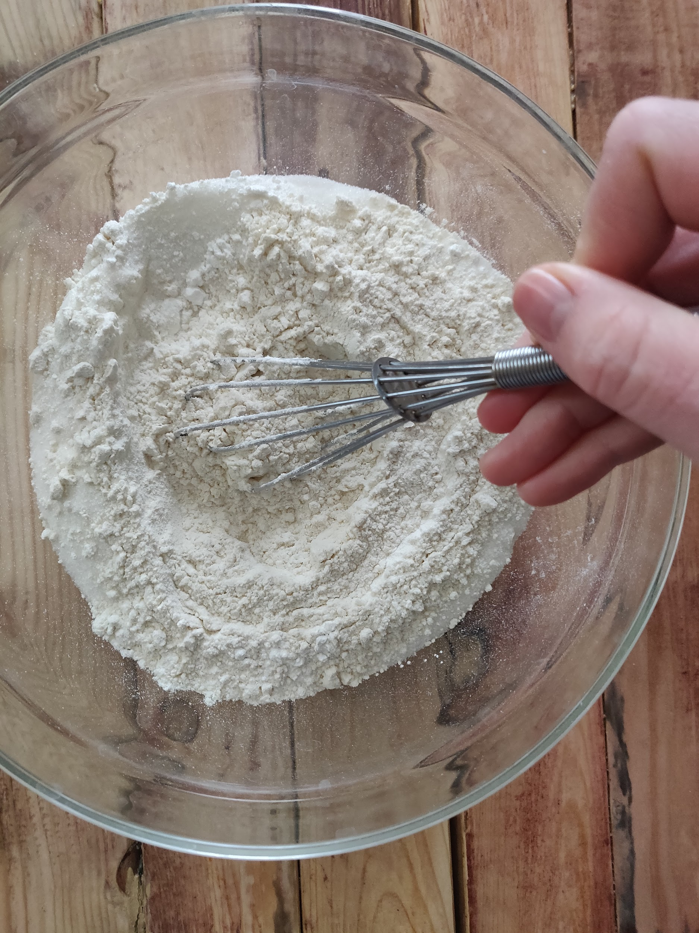

* Try to keep your **Wet Ingredients** cold, because the room temperature and working the dough with your hands will lower the dough temperature and could possibly melt the butter before the scones get into the oven. We want the butter to melt as the scones bake to create a soft interior with a gentle crumb. You can use milk instead of heavy cream, but your scones will lack some of their richness and the dough will also be wetter. Whisking the wet ingredients together ensures that you don't end up with chunks of egg yolk or white in just one part of the dough, but evenly spread throughout. Whisking also helps to lighten the texture of the scone.

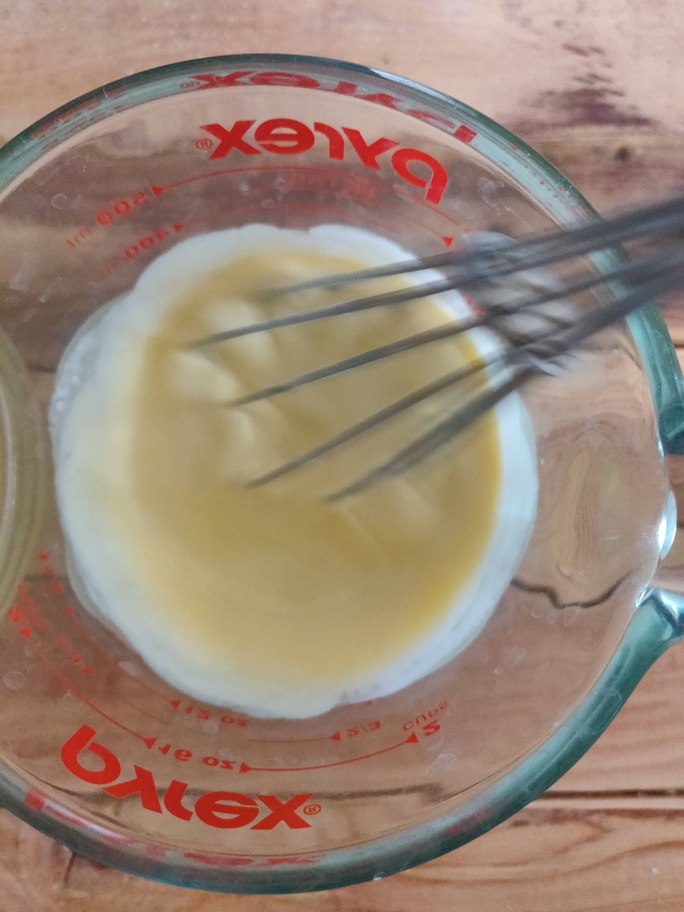

* Always use cold **butter** and if you're using your fingers to blend the cubed butter and the dry ingredients, which I suggest doing, work quickly and only blend them together until most of the butter is as small as a pea. When blending with your fingers, simply make the finger-snapping motion with your thumb, pointer and index fingers. It's called snapping the dough. You *can* use a pie dough cutter instead of your fingers, but one of the small pleasures of baking is getting your hands down and dirty in the dough!

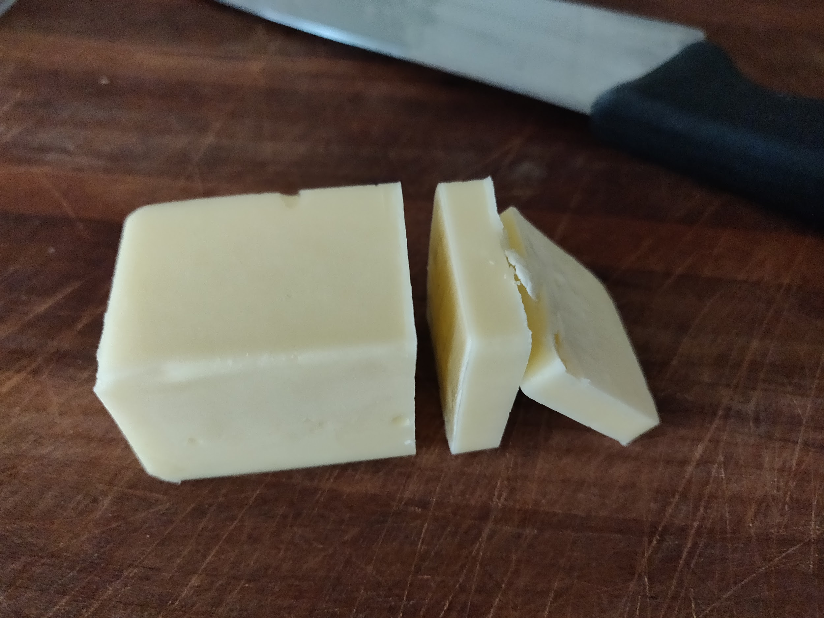

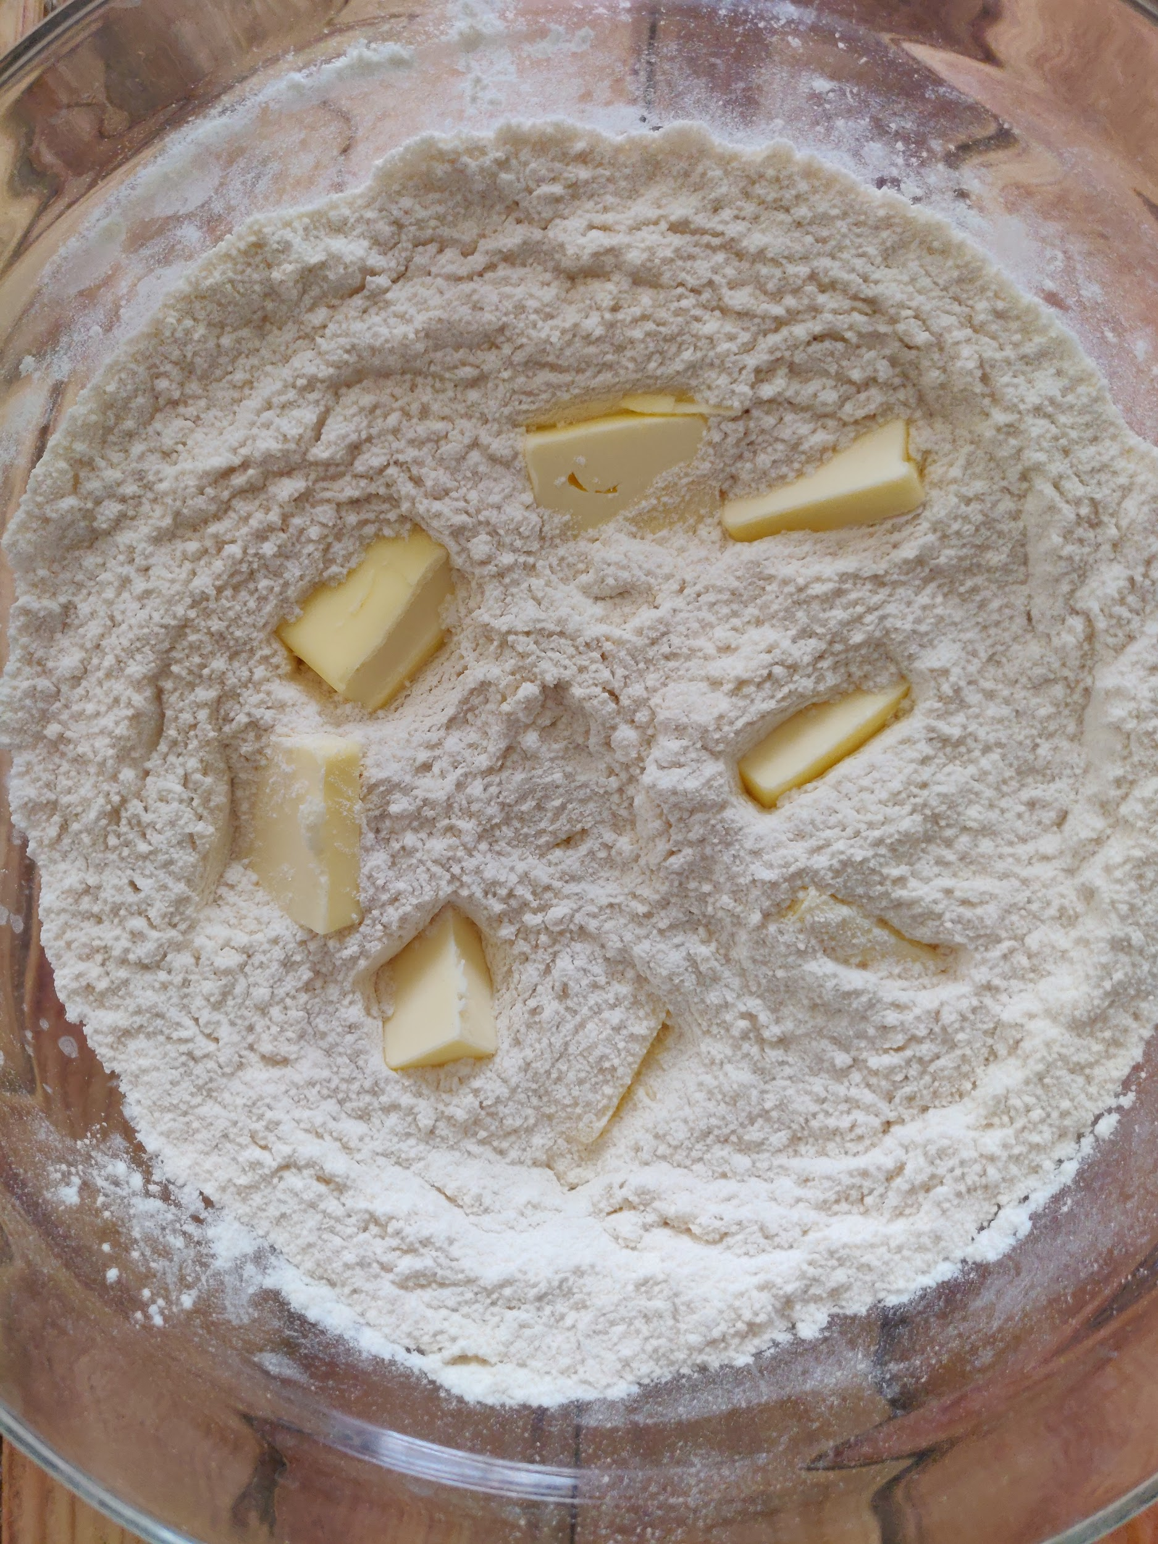

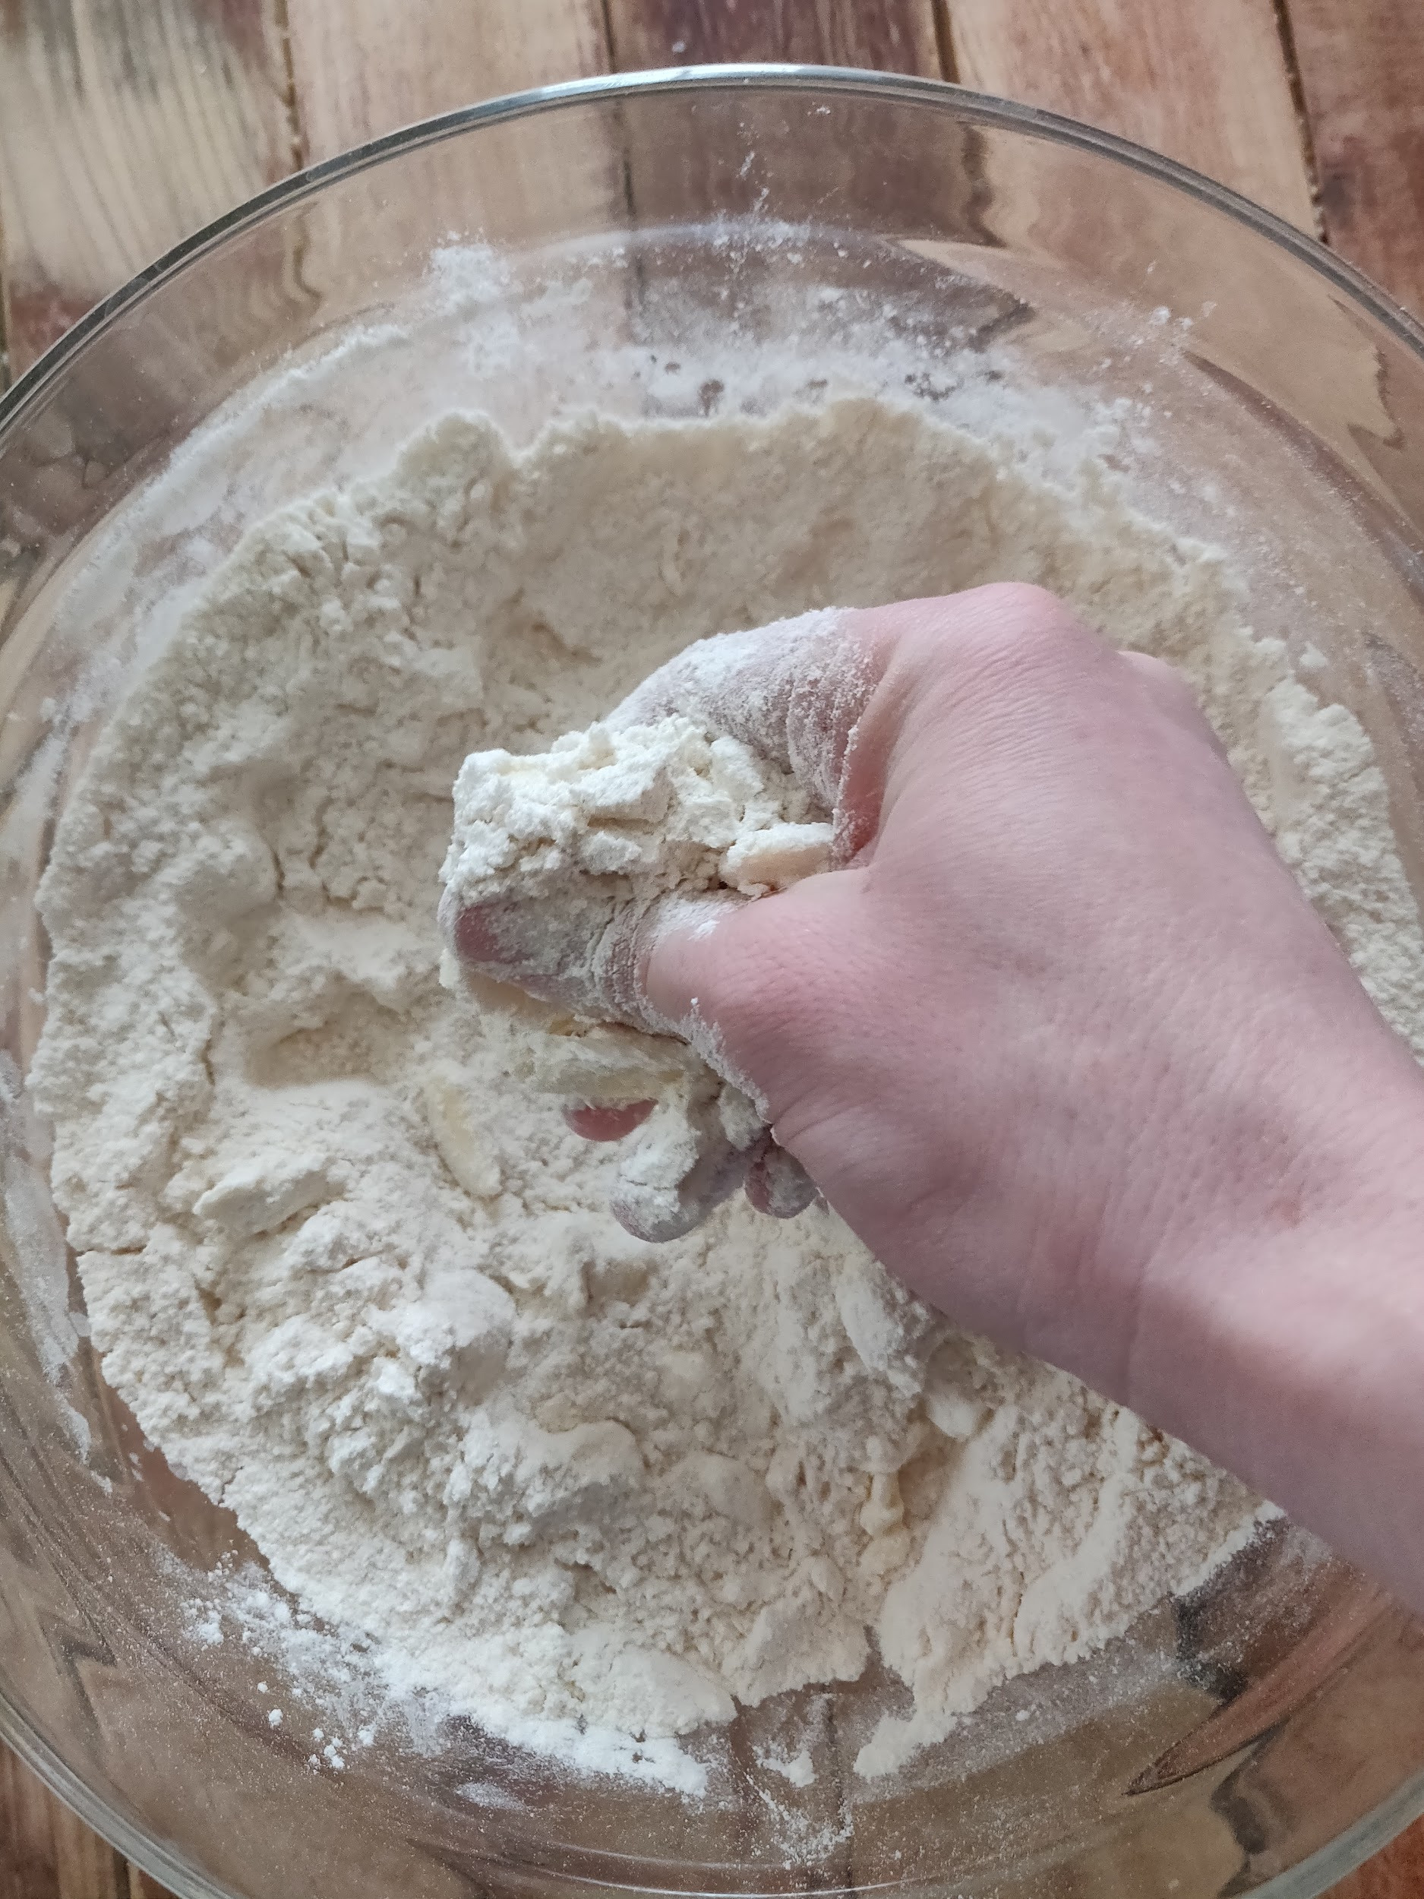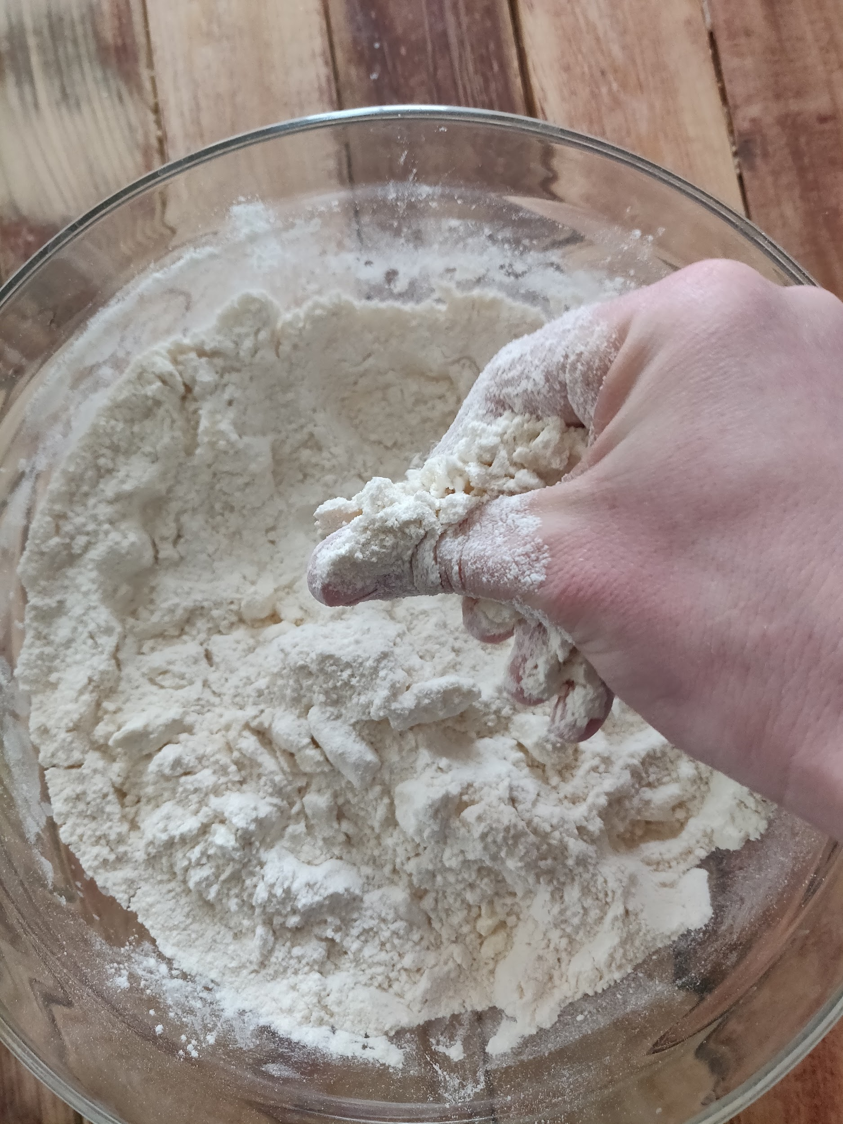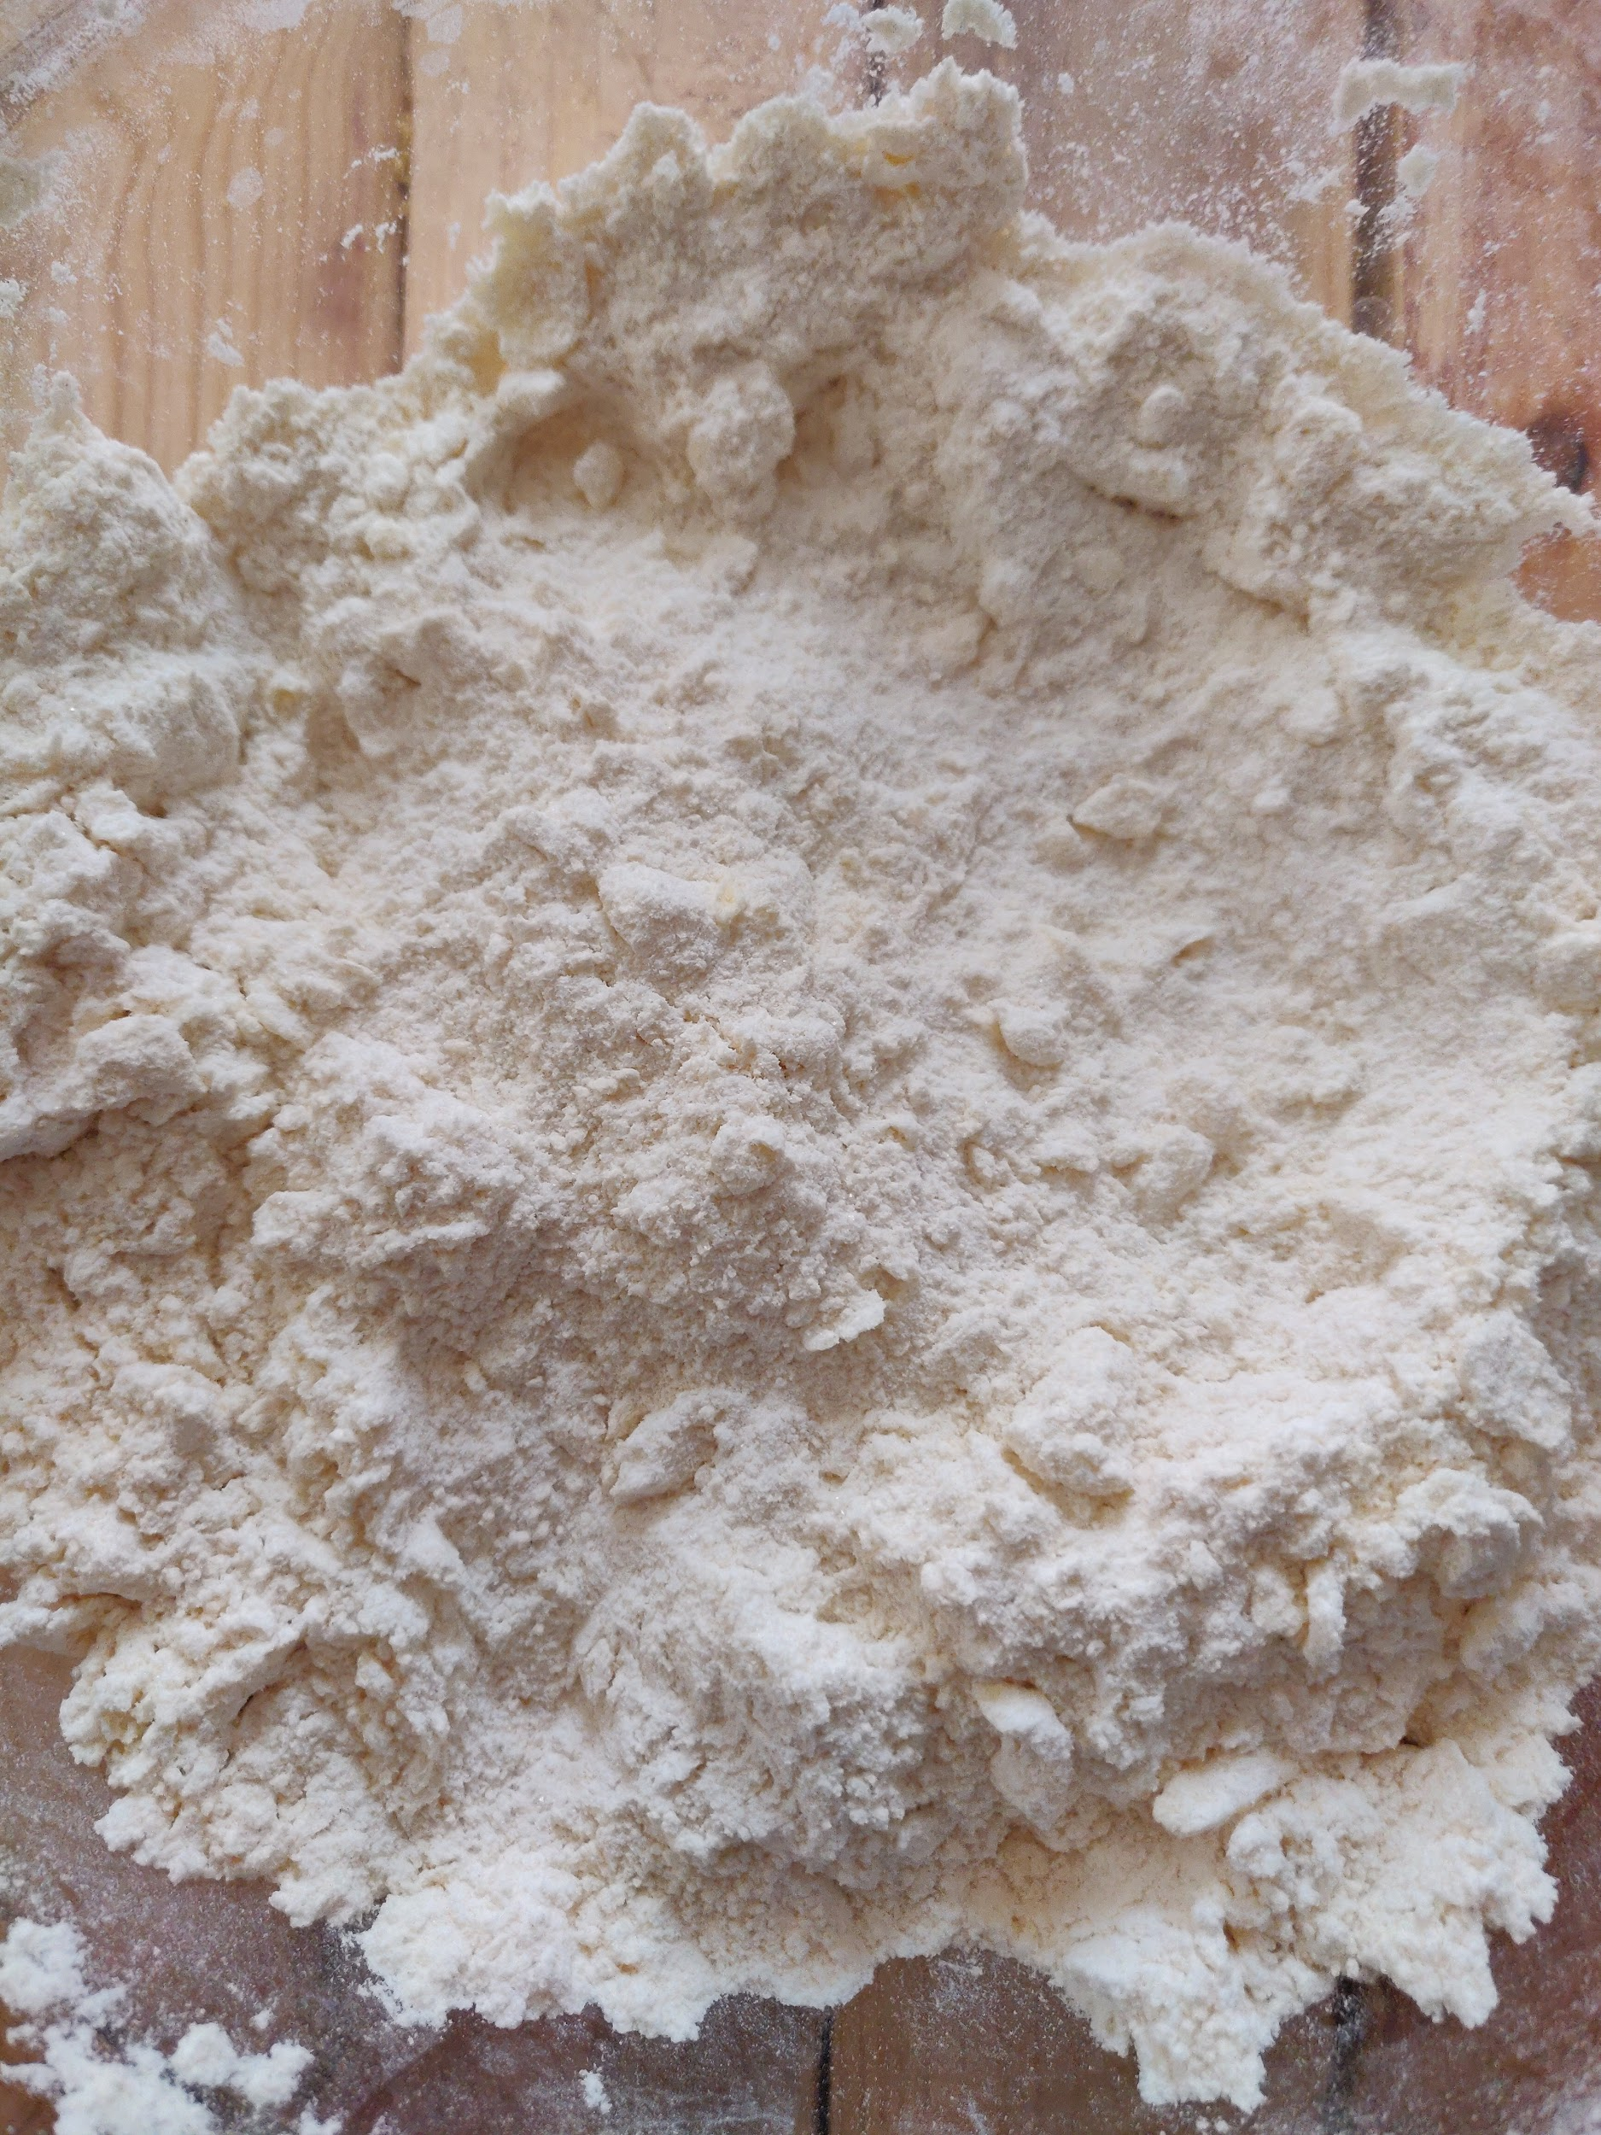

* Now we get to the messy part: **mixing.** Pour your desired add-ins into the flour mixture, pour in the wet ingredients and with a fork, gently mix until large clumps of dough form. At this point roll up your sleeves and finish mixing the dough with your hand. One hand holds the bowl and the other softly folds the clumps into one mass of dough. There may be some random chunks of flour that don't want to stick to the main dough ball and that's alright; just toss the excess.

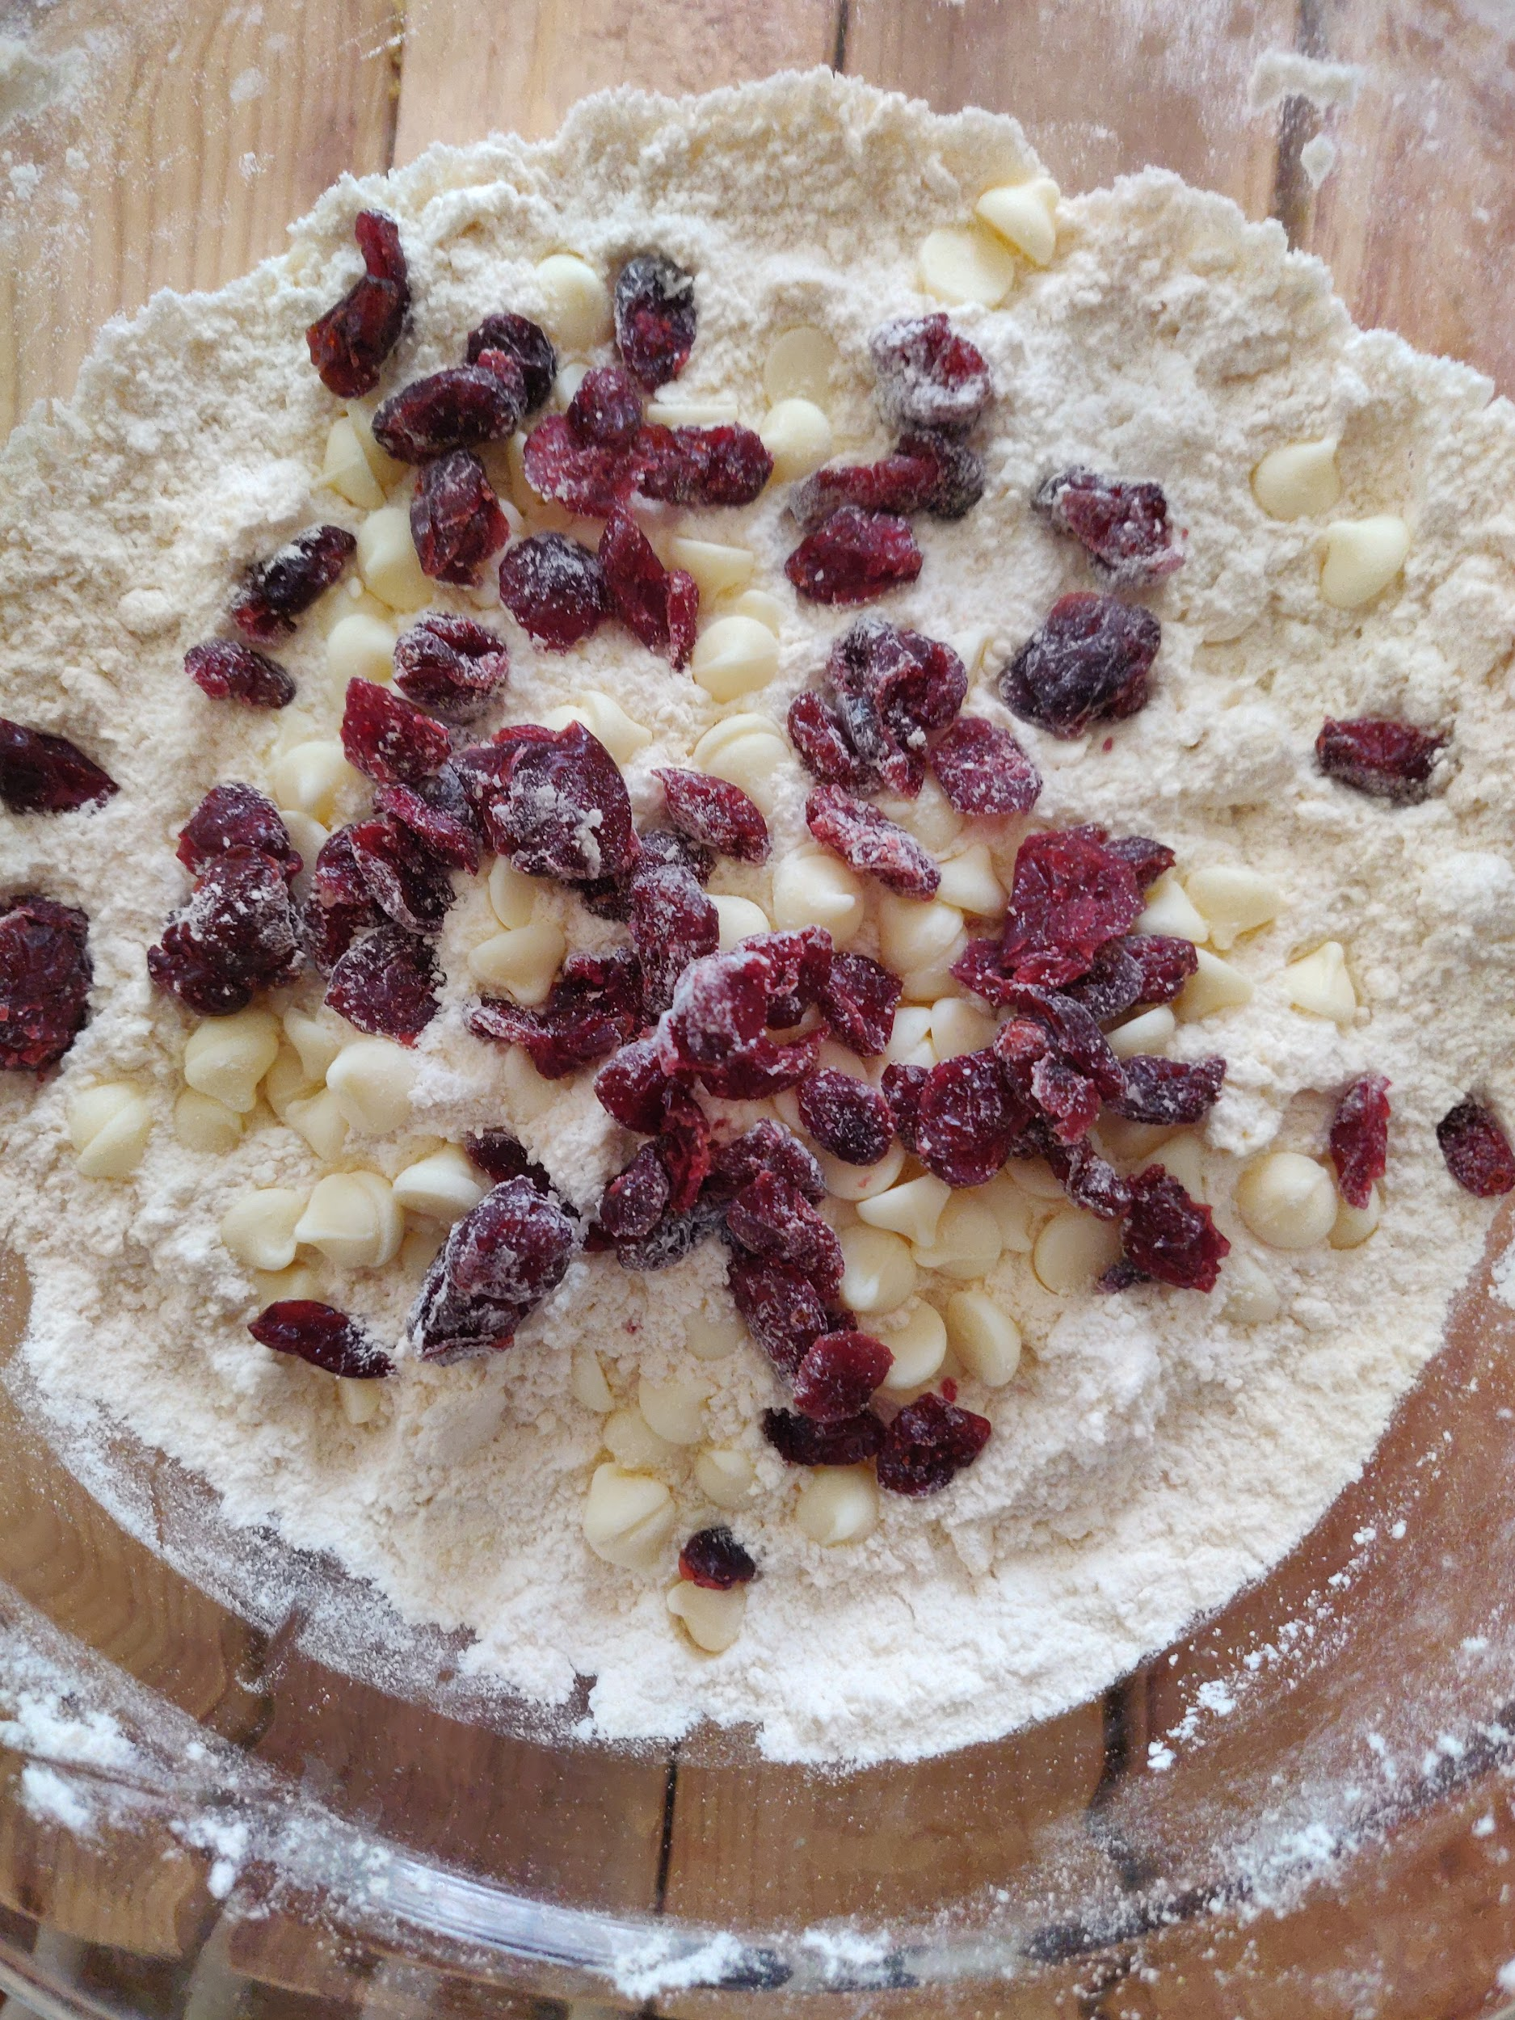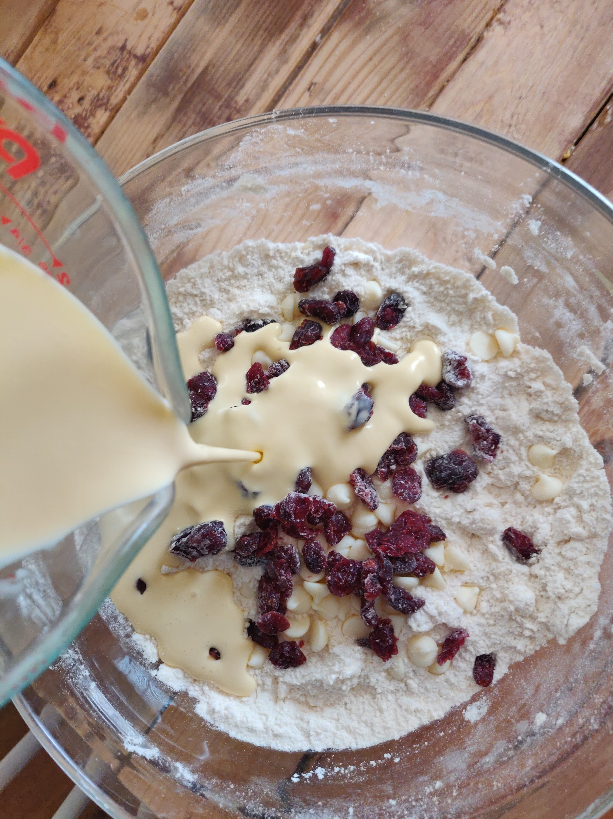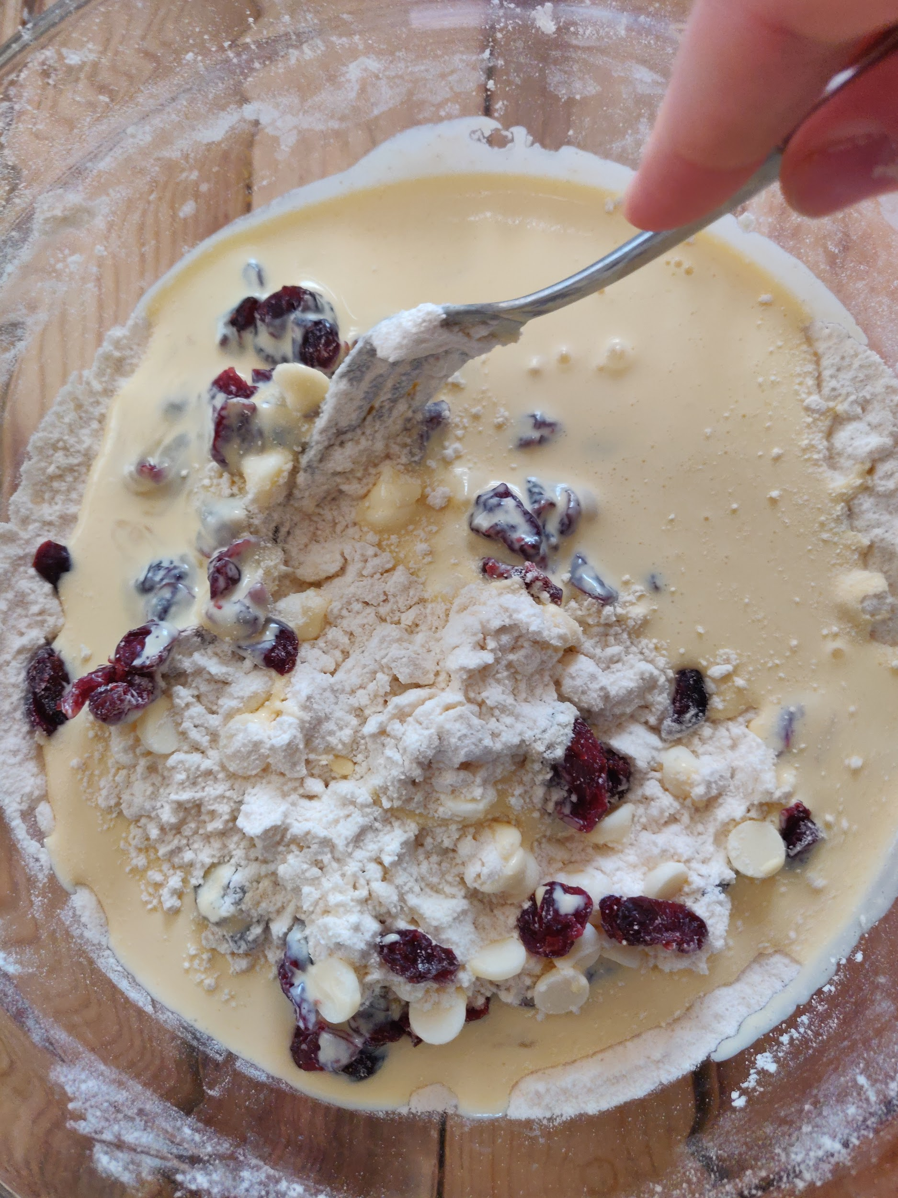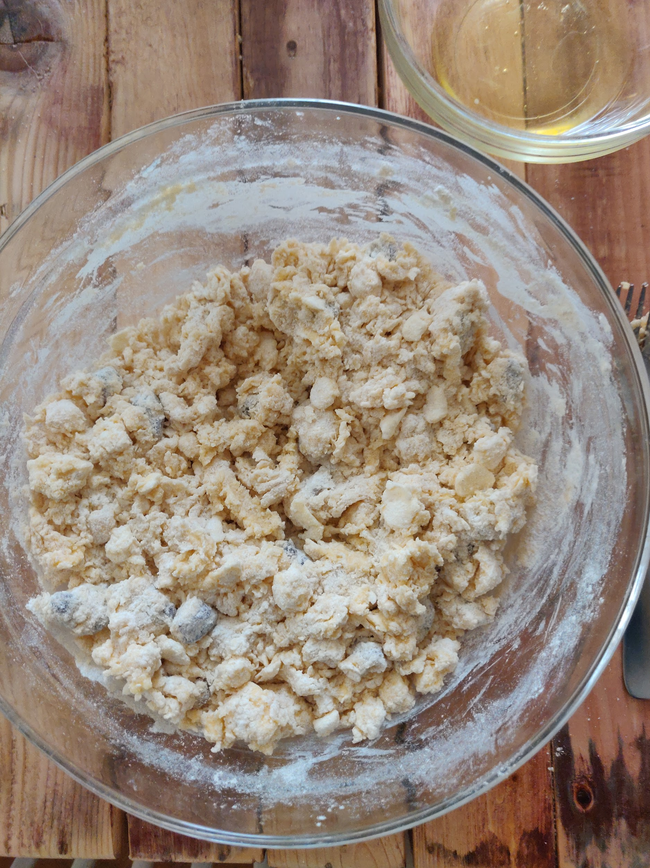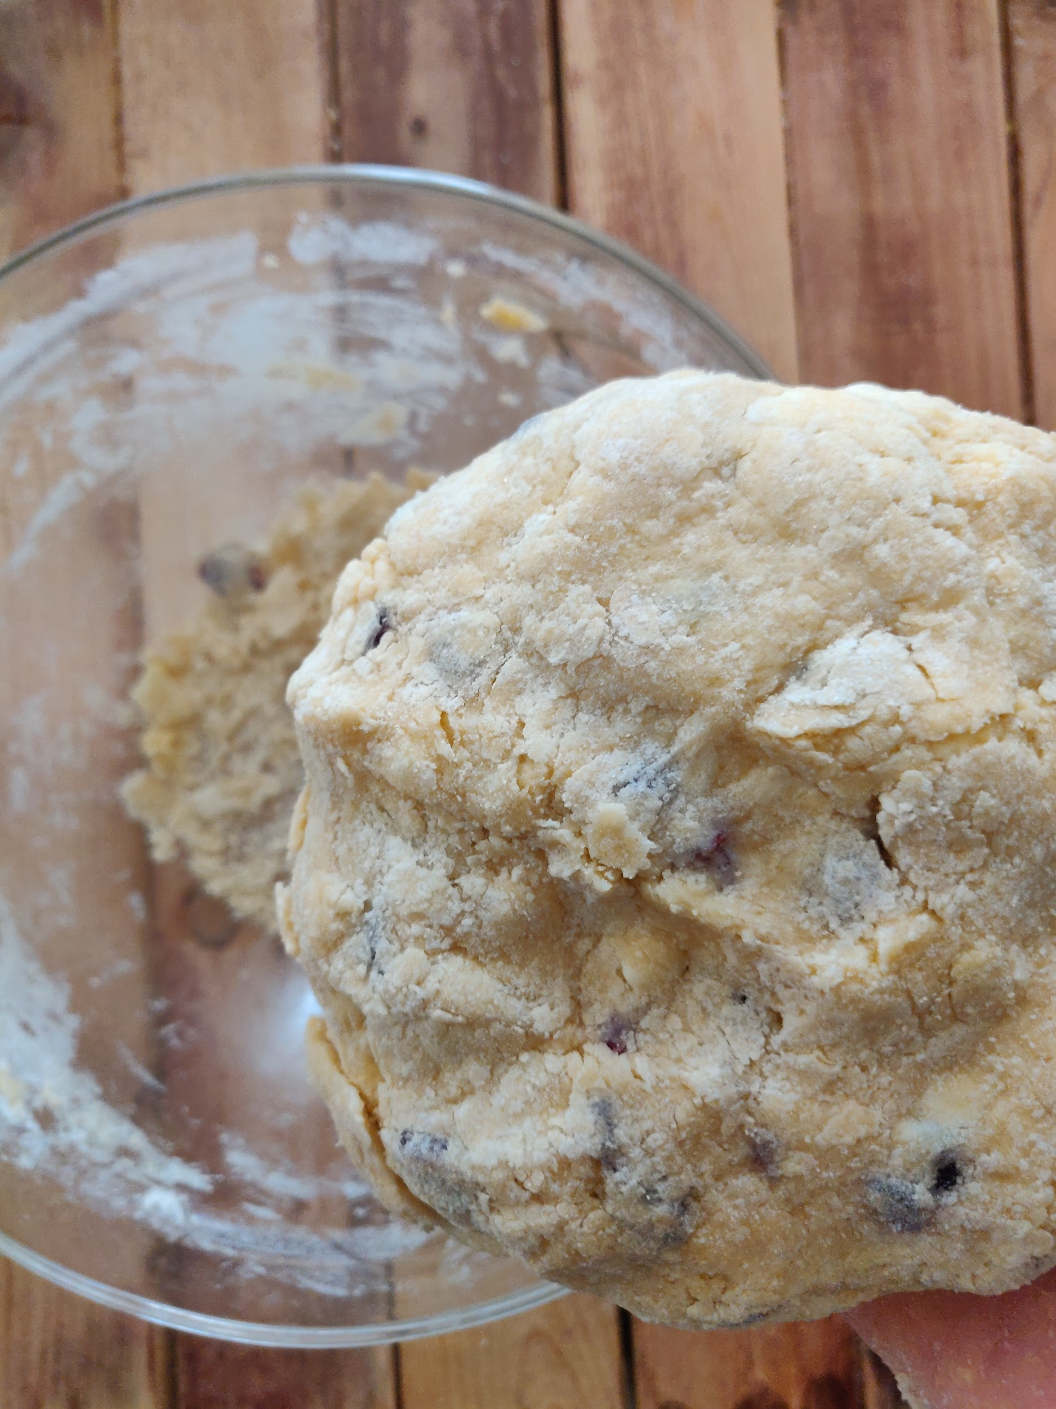

* Next up is the forming of the triangles. This sounds super powerful and daunting, but it's actually super easy and does not produce any powers, unless you call everyone wanting to be your friend because of your scones a superpower. Some people say that it is better to cover and refrigerate your dough before cutting and baking them, but I have found no significant difference between refrigerating and immediately cutting the dough, aside from a longer waiting period before I can stuff these delicious scones into my belly! If you want six large scones, form the dough into a 4” x 10” rectangle. The more scones you want from a single batch, the skinnier and longer you want the rectangle to be. I use a metal bench scraper to form nice straight sides and 90° angles.

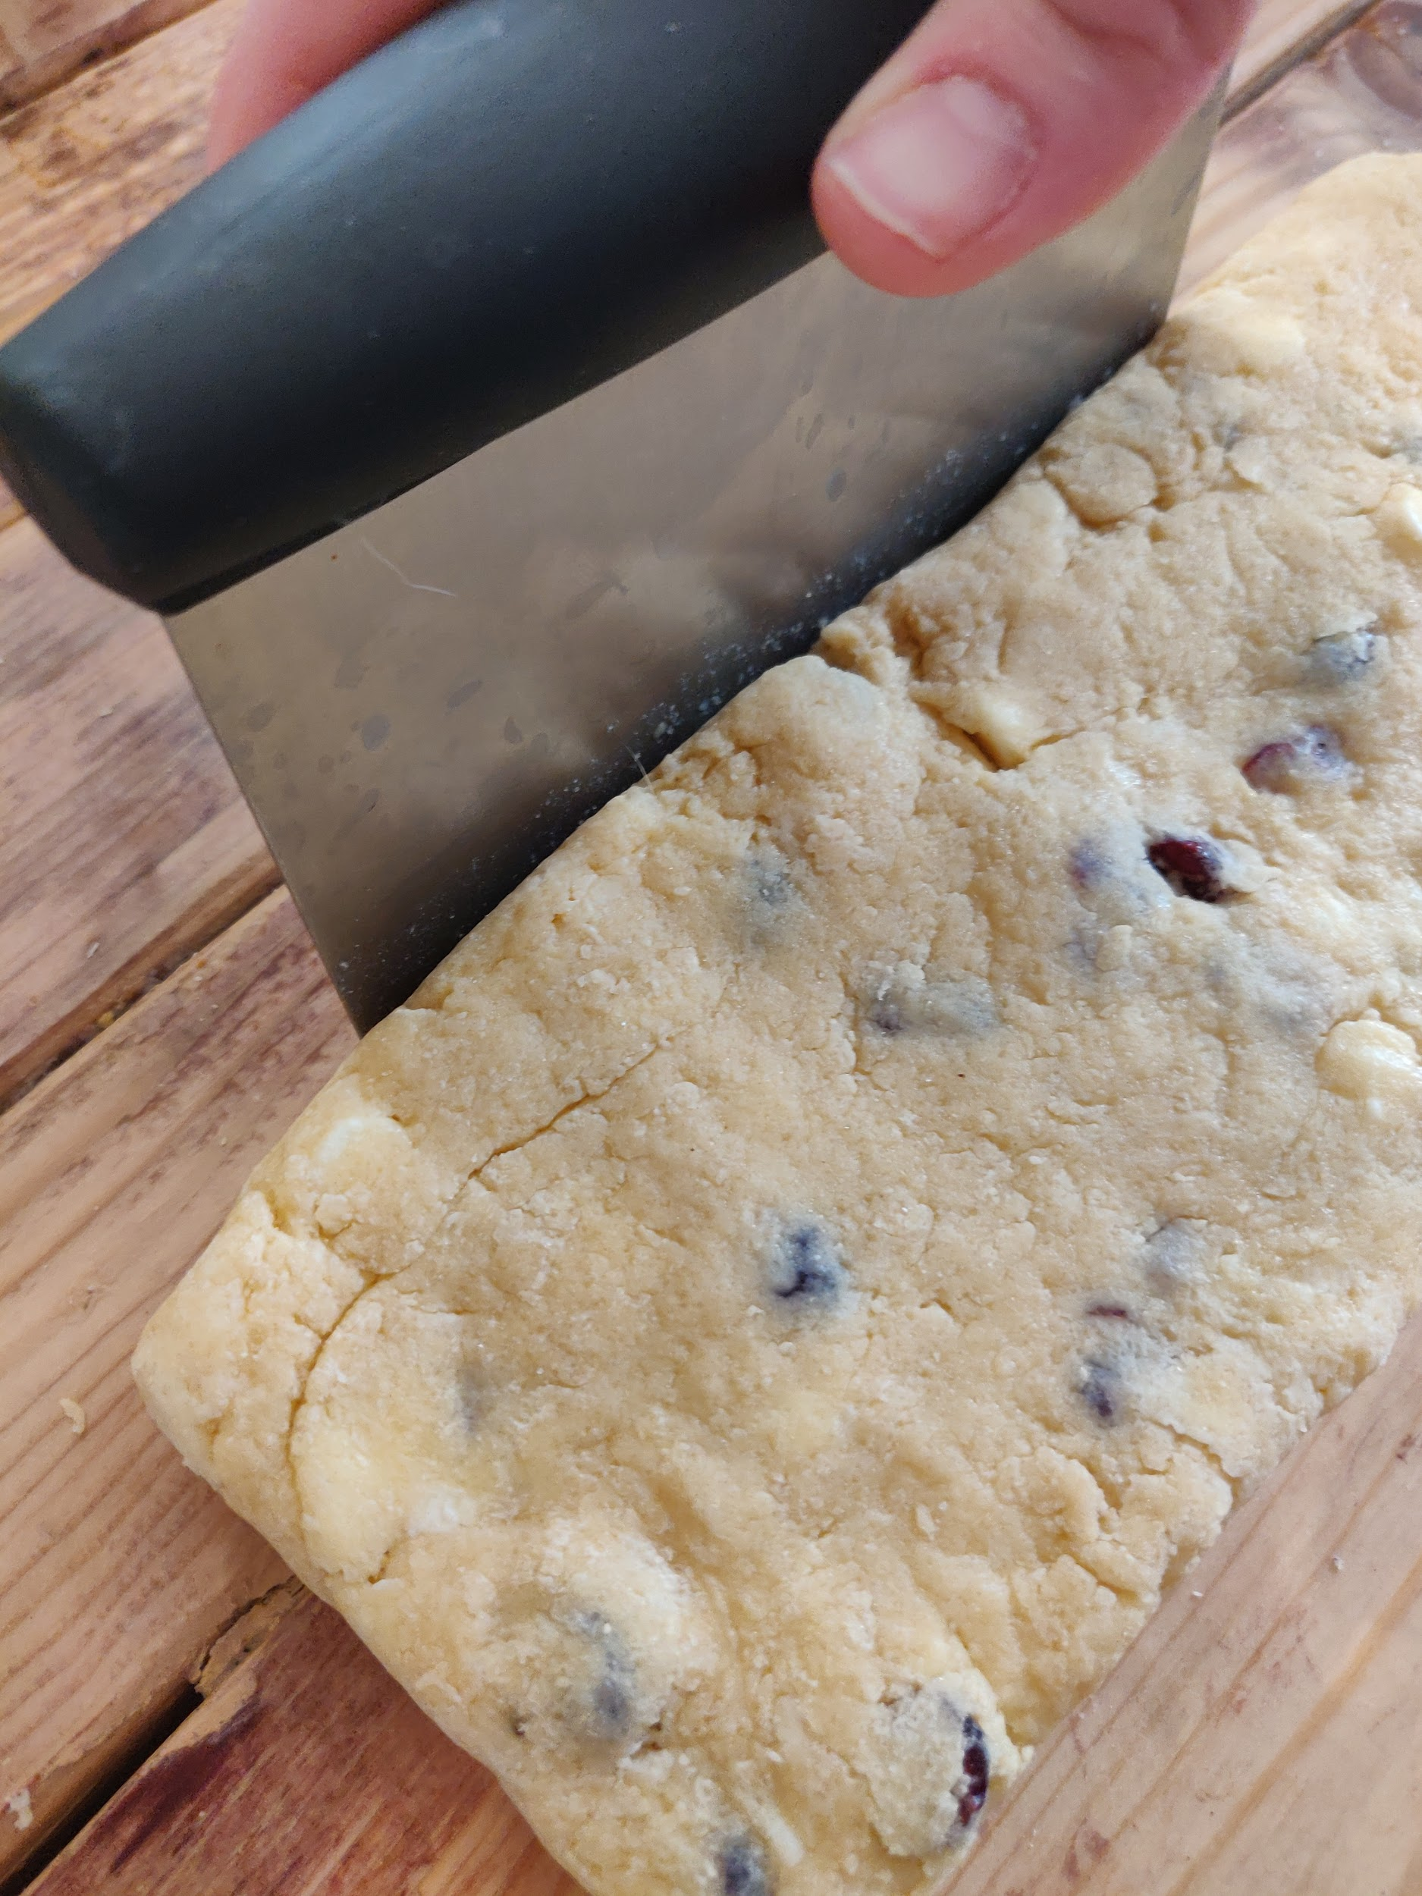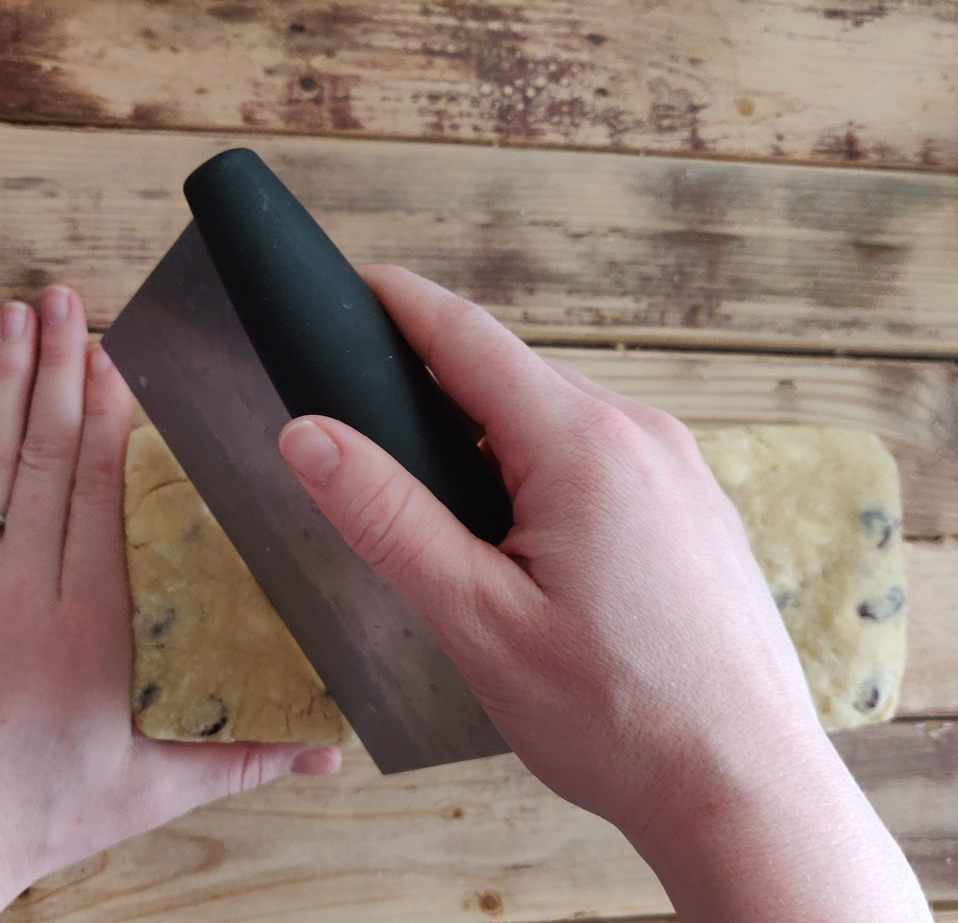

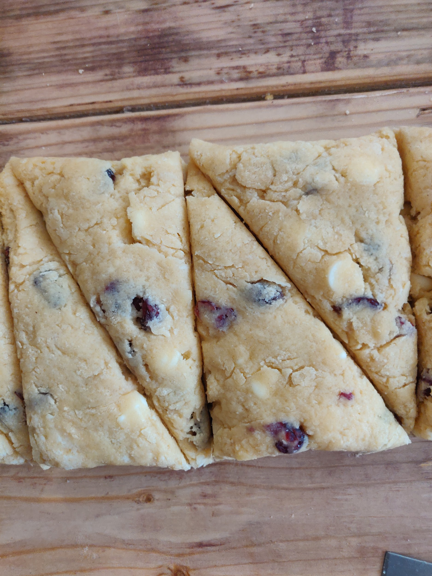

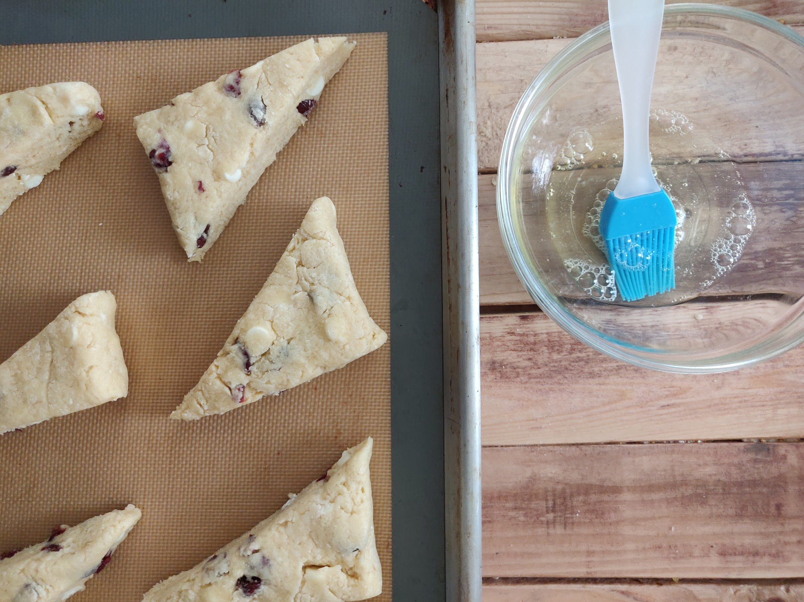

* Once the stones are formed and laid out on your baking sheet, baste them with your reserved egg white, sprinkle them with sugar, and throw them in a 400° oven for about 13 - 15 minutes. You'll know they're done when they are golden brown and bounce back when you gently press on them with your finger.

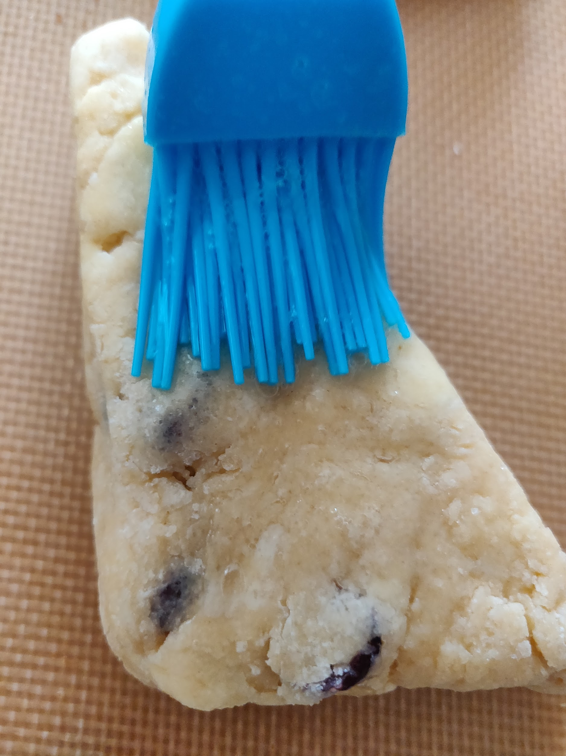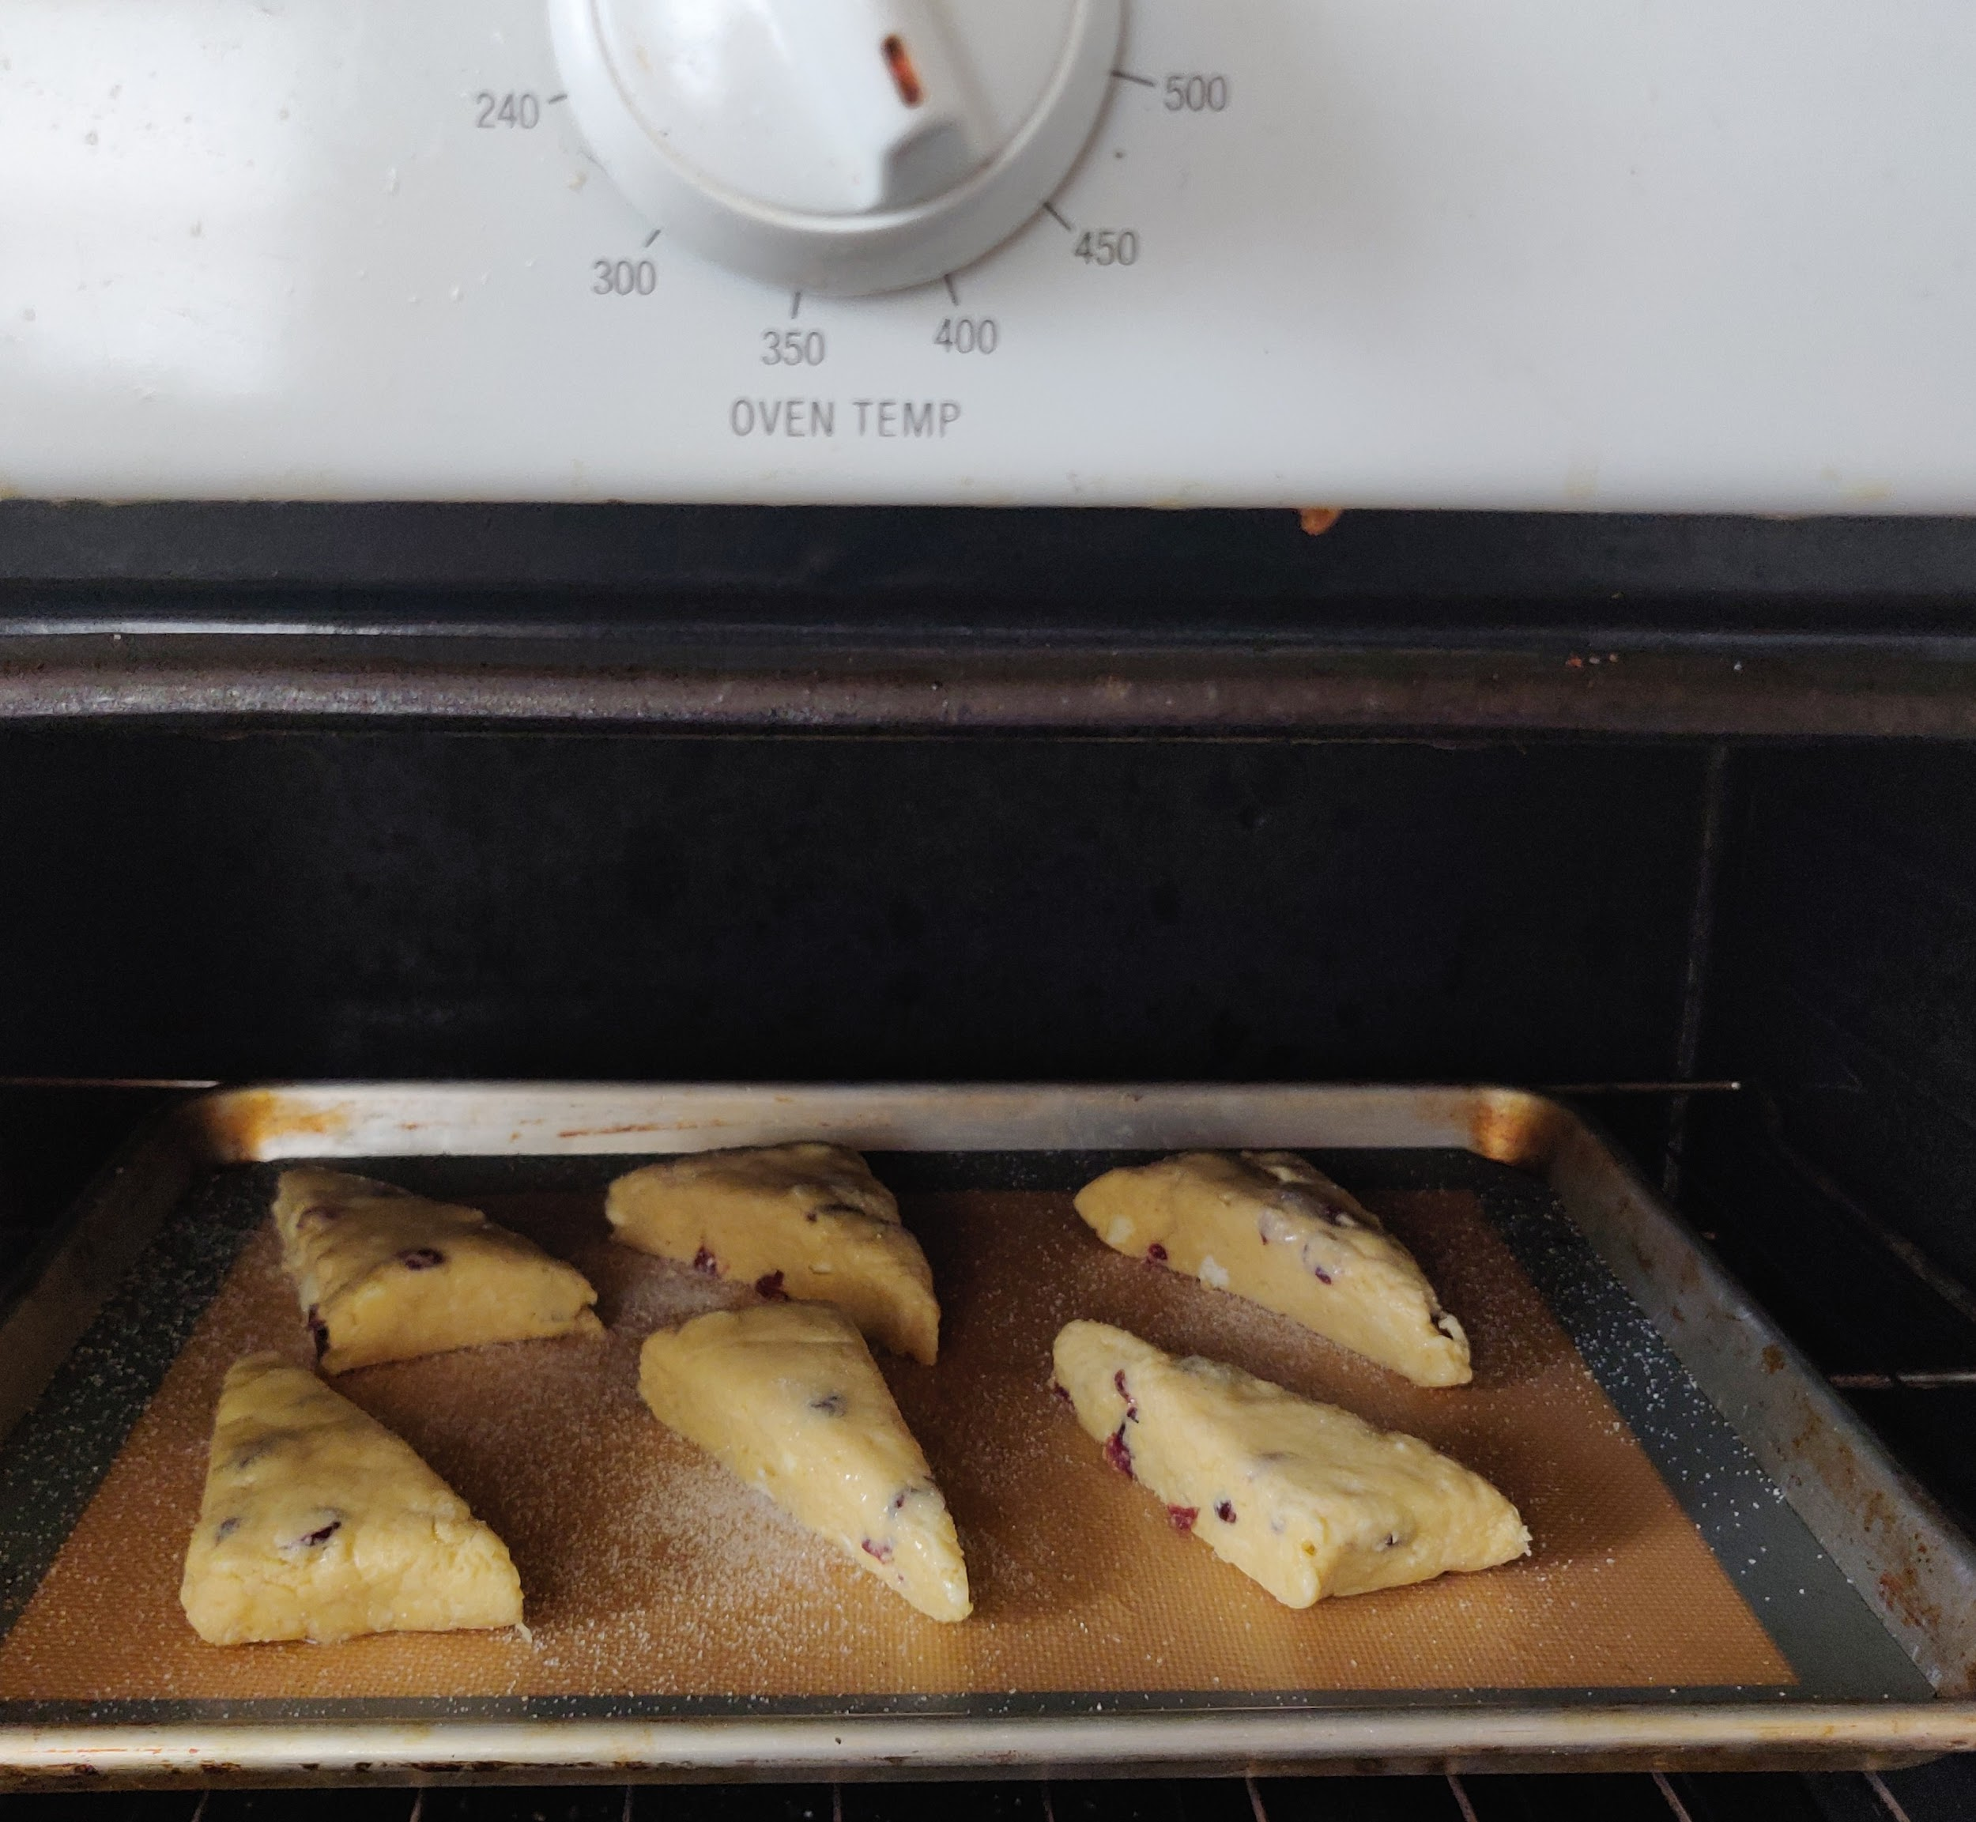

These scones are so quick and easy to put together, that there really is no need for cutting corners (I used to be very very impatient when it came to baking and I always thought that I knew best and would try to cut corners…let's just say that I've learned quite a lot from actually following recipes exactly)!   
  
INGREDIENTS:  
2 cups All Purpose Flour  
1/2 cup Granulated Sugar  
1 T. Baking Powder  
Pinch of salt  
1/4 cup Cold Butter  
1/2 cup Heavy Whipping Cream  
1 whole egg  
1 egg yolk ( reserve the egg white)  
1 tsp Vanilla Extract  
1/2 cup dried cranberries  
1/2 cup white chocolate chips  
Granulated Sugar for sprinkling

THE PROCESS:

In a medium mixing bowl whisk together the flour, sugar, baking powder and salt. In a separate mixing bowl, whisk together the cream, egg, yolk, and vanilla. Now cut your butter into the dry ingredients. Use either a pastry cutter or your fingers by snapping the butter between your fingers until the butter is blended in and about the size of split peas. Next, pour your berries and chocolate chips into the flour mixture, pour in the cream mixture, and gently stir together with a fork. Stir until large clumps of dough form, then form the dough into a ball with your hands by gently folding the dough. Lightly flour your work surface. Place dough on floured work surface and gently press into a long rectangle. Cut into 6 large triangles or into 10 smaller triangles.

Preheat oven to 400°F. Place scones on to silicon mat, baste them with the reserved egg white, then sprinkle with granulated sugar. Bake for about 13 minutes or until they are golden brown and have a slight spring when pressed with the finger.

Serve them straight from the oven or at room temperature! Enjoy!